# SignEase: A Comprehensive Platform for Learning Sign Language

##### **Priyanka V Gudada* Bellapukonda Pooja**, G Kullayi Reddy***, S Tejo Raditya****, A Lakshmi Poojitha\*\*\*\*\***

* CSE(AI), Dayananda Sagar Academy of Technology & Management, <priyanka-csai@dsatm.edu.in>

** CSE(AI), Dayananda Sagar Academy of Technology & Management, [1dt22ca011@dsatm.edu.in](mailto:1dt22ca011@dsatm.edu.in)

*** CSE(AI), Dayananda Sagar Academy of Technology & Management, [1dt22ca018@dsatm.edu.in](mailto:1dt22ca018@dsatm.edu.in)

**** CSE(AI), Dayananda Sagar Academy of Technology & Management, [1dt22ca041@dsatm.edu.in](mailto:1dt22ca041@dsatm.edu.in)

***** CSE(AI), Dayananda Sagar Academy of Technology & Management, [1dt22ca008@dsatm.edu.in](mailto:1dt22ca008@dsatm.edu.in)

***Abstract*-** SignEase is an innovative platform designed to empower specially-abled individuals and their families by providing an accessible and efficient way to learn sign language. This web-based tool offers a structured four-week curriculum covering basic gestures, alphabets, and conversational skills. A key feature, SignGPT, leverages AI technology to convert textual inputs into sign language animations, enhancing interactivity and learning. The project aims to bridge the communication gap for the hearing and speech-impaired community, making sign language learning engaging and accessible. The platform’s user-friendly design includes interactive videos, daily practice modules, and assessment features to track progress. By utilizing modern web development technologies, SignEase serves as a powerful tool to foster inclusivity and understanding in society.

***Index Terms***- Sign language learning, SignGPT, AI-powered education, inclusive communication, accessibility.

1. Introduction

In a world driven by communication, the hearing and speech-impaired community often face significant challenges due to a lack of accessible resources for learning sign language. SignEase addresses this pressing issue by offering a comprehensive online platform to facilitate sign language learning for specially-abled individuals and their families.

The primary aim of this project is to create an inclusive environment that bridges the communication gap. The need for such a platform is underscored by the growing emphasis on diversity, equity, and inclusion in society. SignEase leverages advanced technologies, such as AI and web development frameworks, to make learning engaging and efficient.

This project’s societal impact is significant as it empowers individuals to communicate effectively, enhancing their social interactions and independence. By fostering inclusivity, SignEase contributes to building a more understanding and compassionate society.

1. BASIC CONCEPTS/ TECHNOLOGY USED

SignEase integrates cutting-edge technologies to create an immersive, interactive, and accessible learning experience for individuals interested in mastering sign language. Below are the core technologies that form the foundation of this innovative platform.

Artificial Intelligence (AI) is the backbone of SignEase, enabling the development of its standout feature, SignGPT. SignGPT leverages Natural Language Processing (NLP) to interpret user-inputted sentences, transforming textual content into corresponding animated sign language gestures. This process relies on advanced machine learning algorithms trained on diverse datasets to ensure accuracy and fluency in translation. AI also facilitates real-time customization of animations, ensuring learners engage with contextually accurate signs tailored to their needs.

The platform’s user interface is built using modern web development frameworks like HTML, CSS, and JavaScript. React.js, a popular library, ensures a dynamic and responsive interface that adapts seamlessly to different devices and screen sizes. The design prioritizes user-friendly navigation, allowing learners to access resources, switch between weeks, and track their progress effortlessly. Interactive elements, such as buttons and visual cues, enhance engagement and usability.

High-quality instructional videos form a significant part of SignEase’s curriculum. Modern APIs enable seamless video embedding to provide clear and consistent content delivery. Additionally, local storage options allow users to upload their practice videos, fostering personalized learning. This feature ensures that learners can revisit their practice sessions and receive targeted feedback based on their unique progress.

The platform incorporates cutting-edge technologies like OpenCV and TensorFlow for real-time camera integration. These tools enable users to practice gestures by mirroring them in front of their cameras. The system provides instant feedback on gesture accuracy, helping learners refine their skills effectively. Gesture recognition powered by machine learning algorithms ensures the assessments are accurate and adaptive to individual user performance.

Together, these technologies create a powerful, user-friendly platform that redefines sign language education. By leveraging AI, modern web development frameworks, real-time feedback systems, and analytics, SignEase ensures learners have access to a comprehensive and engaging resource for mastering sign language.

1. Study of similar projects or technology\ literature review

The development of **SignEase**, an innovative platform for learning sign language with an integrated feature called SignGPT, requires a thorough examination of prior research and technological advancements in gesture recognition and language learning systems. This section reviews notable studies in the field, focusing on the features, challenges, and technological approaches that influenced the project.

In the realm of **gesture recognition**, researchers Gabriel Serrano and Daehan Kwak[1] explored the use of computer vision and artificial intelligence for real-time gesture detection. Their work emphasized the importance of handling variations in environmental conditions, such as lighting changes and background noise, to ensure system robustness. They demonstrated how integrating deep learning models can improve the precision of gesture recognition, particularly in real-time applications. However, their research also highlighted challenges, including the difficulty of recognizing complex, sequential gestures and the need for significant computational resources to maintain real-time performance. Furthermore, inconsistencies in how individuals perform gestures posed difficulties for achieving uniform accuracy across diverse users

Another study by Tangfei Tao and Yizhe Zhao[2] investigated the application of traditional and deep learning methods for gesture recognition. Their work underscored the potential of combining multi-modal data inputs—such as videos, depth maps, and sensor data—to improve recognition accuracy. A key contribution of this research was the emphasis on dataset standardization, which can establish benchmarks and enhance system scalability to support multiple sign languages. Despite these advancements, limitations such as handling dynamic gesture sequences, achieving real-time efficiency, and inconsistencies in gesture datasets remained significant obstacles to broader adoption

Research by Saurav Kumar and Pratiyush Kumar[3] explored the application of Convolutional Neural Networks (CNNs) for hand gesture recognition. CNNs demonstrated high accuracy in classifying gestures, even in varied lighting and background conditions. The scalability of CNN-based models for diverse sign languages and their ability to handle real-time inputs made them a promising approach for systems like SignEase. However, the researchers noted challenges such as the need for extensive, annotated datasets and the high computational requirements of deep learning models. Another critical challenge identified was ensuring that models generalized well to different users, environments, and hand shapes

These studies provided crucial insights for the development of SignEase. First, CNN-based architectures were chosen for their proven ability to deliver high accuracy in recognizing gestures across various conditions. Second, the importance of building a diverse, annotated dataset to address data limitations was emphasized. Third, efforts were directed toward optimizing the system for real-time performance while maintaining computational efficiency. Lastly, scalability and adaptability for multiple sign languages were prioritized for future iterations of the platform.

In summary, the literature review highlights the significant advancements in gesture recognition technologies while identifying gaps and challenges that SignEase aims to address. By leveraging the strengths of computer vision and deep learning, coupled with user-centered design principles, SignEase aspires to create an inclusive, effective platform for learning and using sign language.

1. Proposed Model / Tool

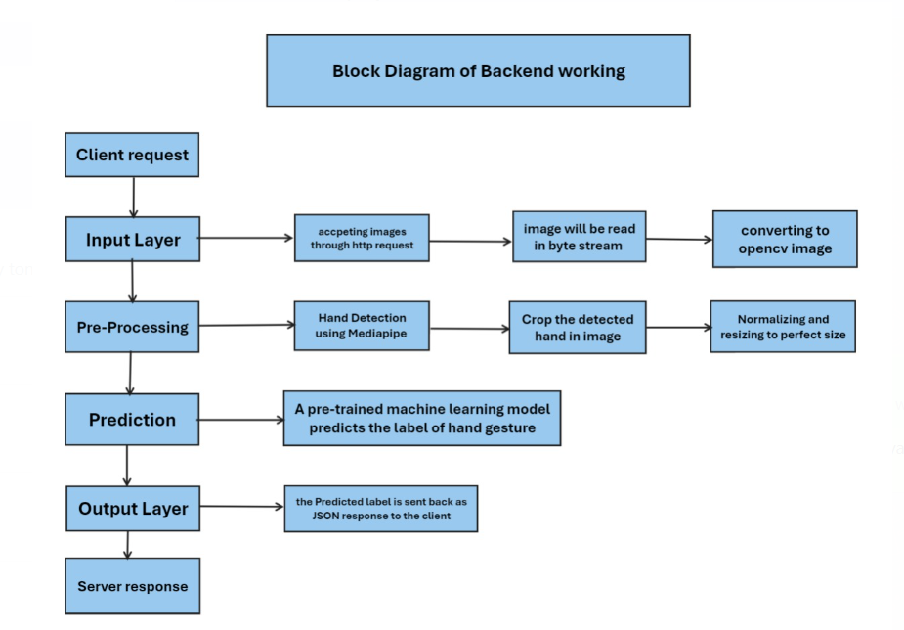

The backend for SignEase is designed to seamlessly process user requests and provide robust functionality. The backend starts with the Input Layer, where it accepts HTTP requests for various functions like user login, signup, and content navigation. For gesture recognition, images are submitted as byte streams and converted to the OpenCV format. The Pre-Processing Layer detects hand gestures using MediaPipe, crops the detected hand region, and normalizes the image for further processing.

Next, the Prediction Layer leverages a pre-trained machine learning model to classify hand gestures and generate corresponding labels. The Output Layer sends the results back as a JSON response, which is used by the frontend to provide real-time feedback. Additionally, the backend manages the database with MySQL, securely storing user credentials, progress, assessment results, and course content. Python scripts ensure smooth integration of functionalities, such as managing the SignGPT feature and dynamically serving course material.

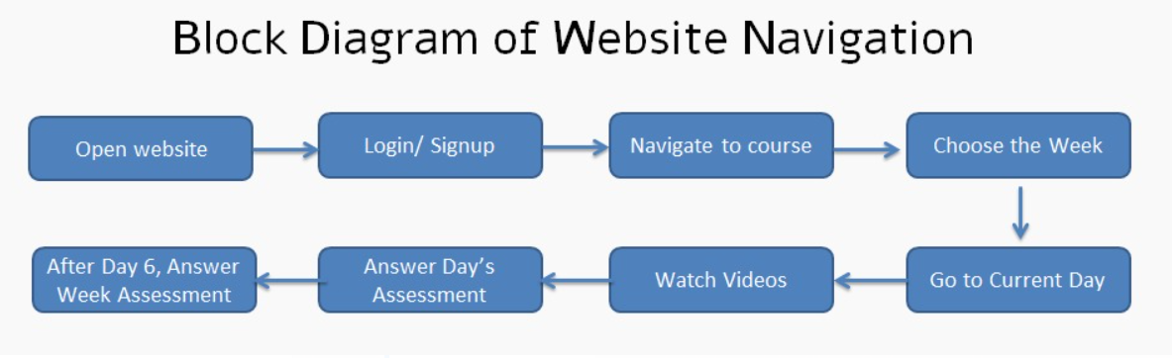

The frontend of SignEase is designed to be intuitive and user-friendly, ensuring a seamless learning experience. Upon visiting the website, users are greeted with the Main Page, which introduces the platform, displays the motto, outlines the course curriculum, and showcases user feedback and frequently asked questions (FAQs). This page serves as the gateway to the platform and helps users familiarize themselves with the system.

Users can then navigate to the Login/Signup Page to create a new account or log in to an existing one. Once authenticated, they are directed to a central Dashboard, which provides access to multiple options, including Week 1, Week 2, Week 3, Week 4, SignGPT, and the option to return to the main page.

Selecting a specific week opens the corresponding Weekly Page, where users can access content organized into Days 1 to 6. Each day includes Instructional Videos and a short Assessment designed to reinforce learning. These resources are tailored to progressively build the user's understanding and skills. After completing all six days of content, users face a comprehensive Week-End Assessment to evaluate their overall progress for that week.

This frontend workflow ensures that users can navigate effortlessly through the platform, access structured learning content, and track their progress. The integration of SignGPT allows users to explore advanced functionalities, making the platform highly interactive and engaging.

1. IMPLEMENTATION & RESULTS

The implementation of SignEase is currently in its initial stages, with conceptual designs and technological frameworks established. The frontend and backend architectures, along with the integration of AI-powered SignGPT, are outlined and prepared for development. The project plans include creating an interactive user interface, seamless backend support, and integrating TensorFlow models for real-time text-to-sign translation.

Although the system is yet to be fully implemented, the expected outcomes are promising. The platform aims to provide an immersive learning experience through dynamic modules, AI-driven text-to-sign translation, and personalized feedback. Users will be able to track their progress, practice gestures with real-time feedback, and develop conversational proficiency in sign language within four weeks.

The anticipated results include increased accessibility and convenience for individuals learning sign language, thereby promoting inclusivity and bridging communication gaps in society.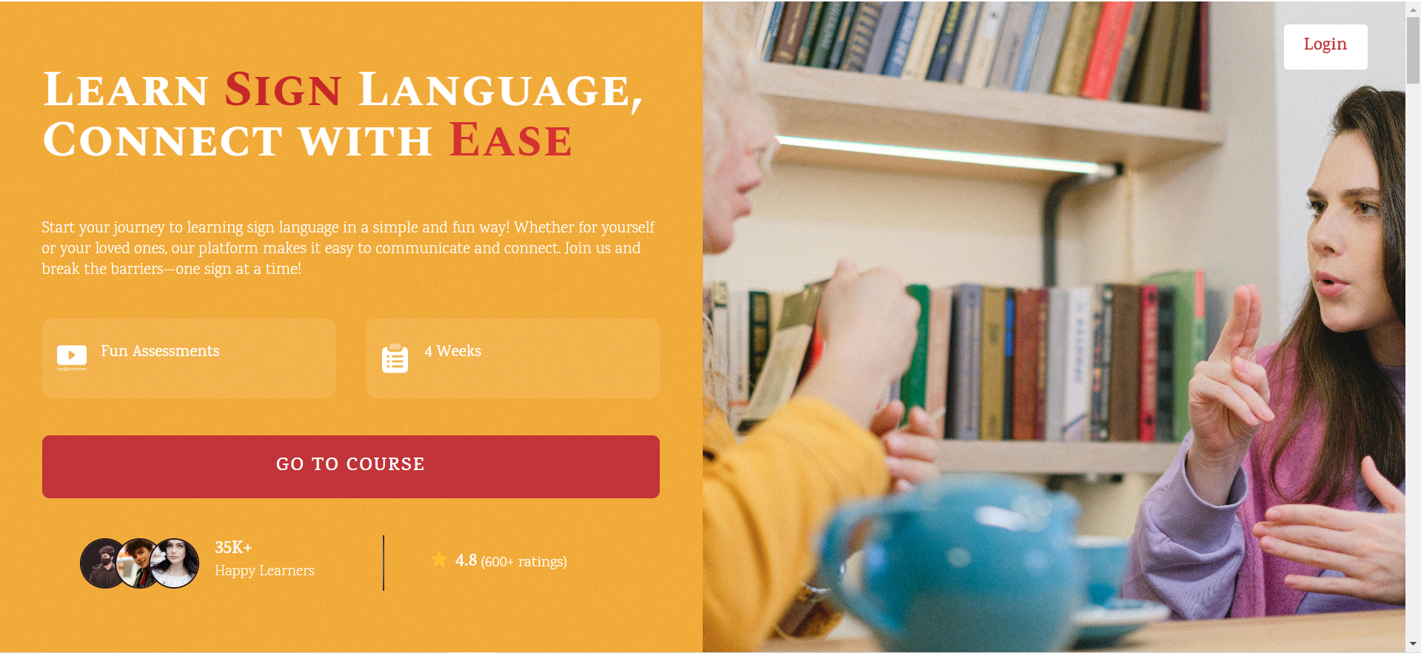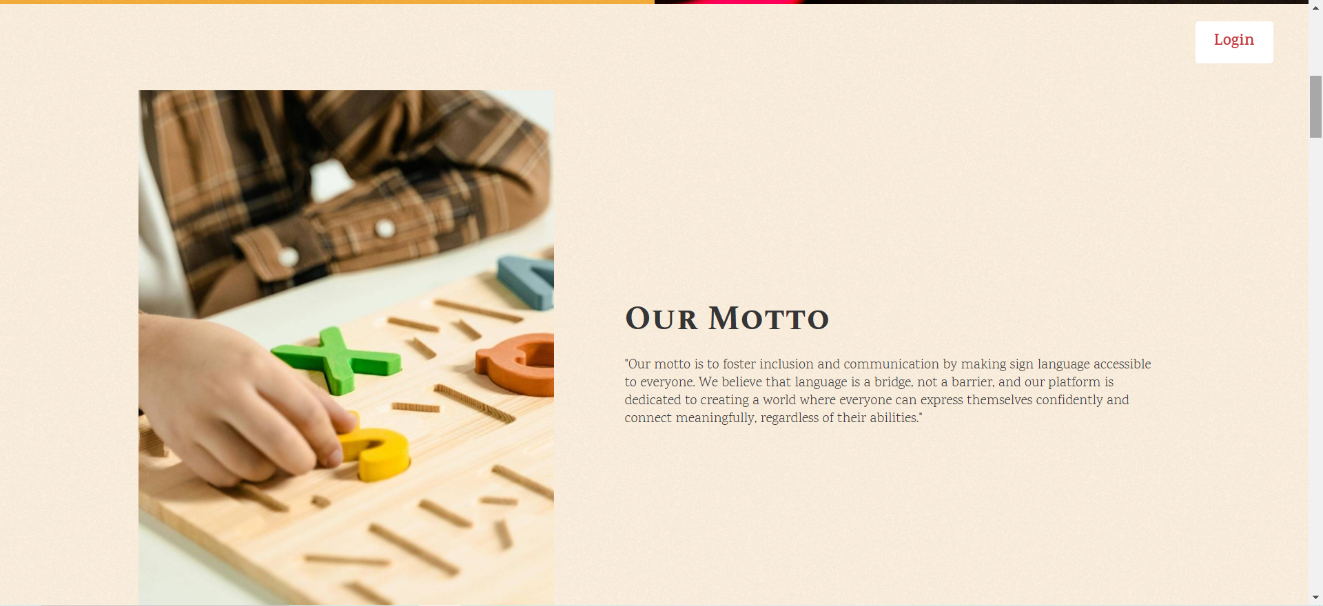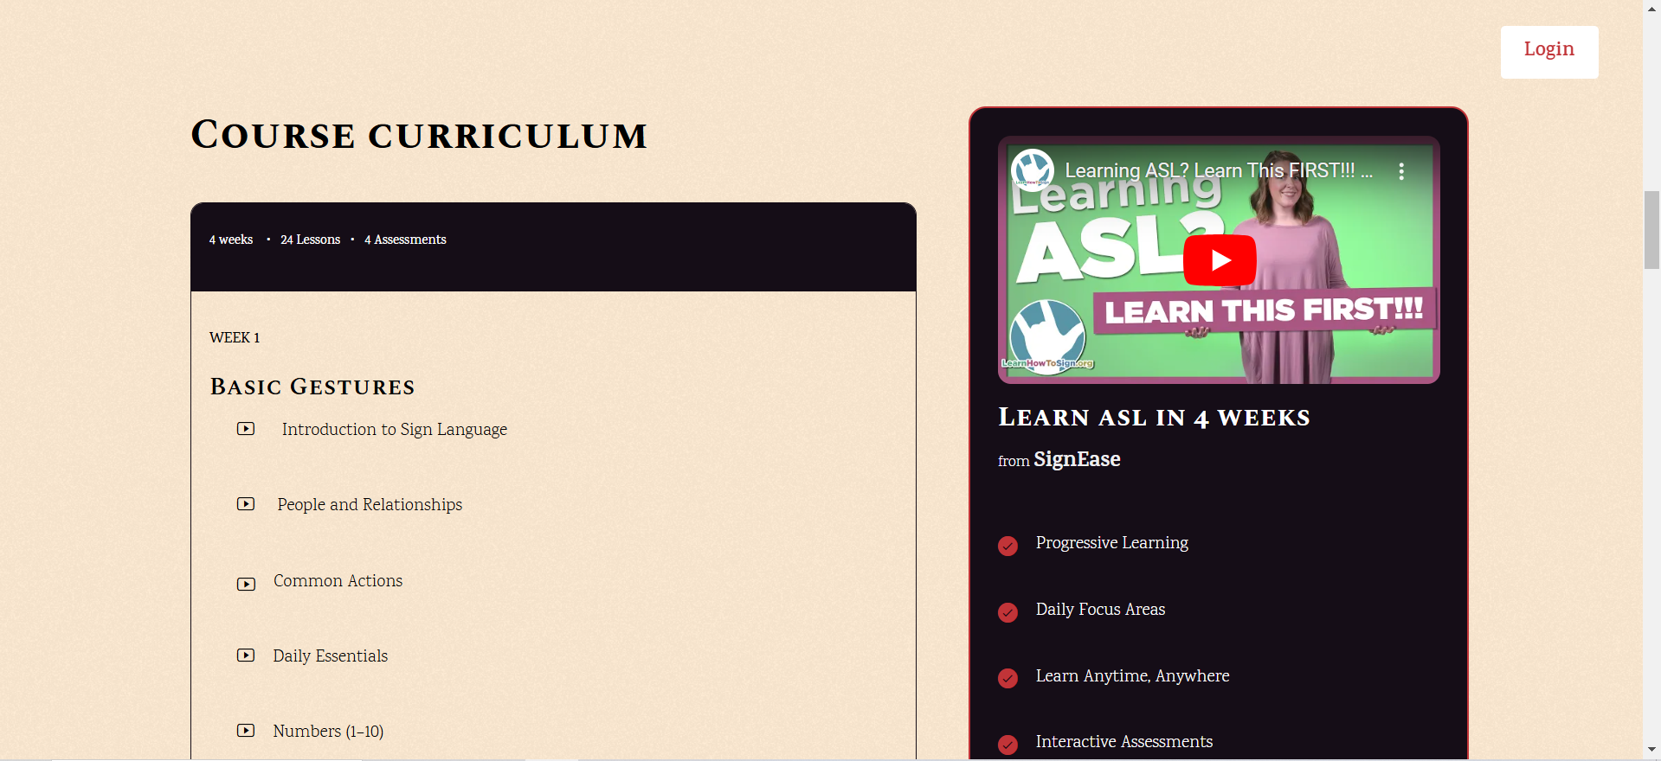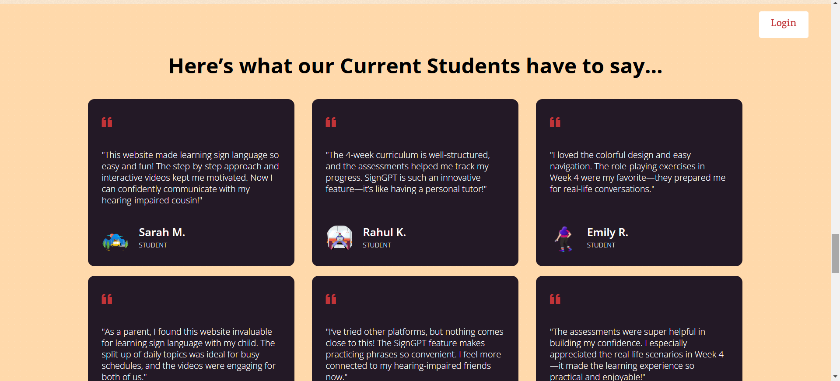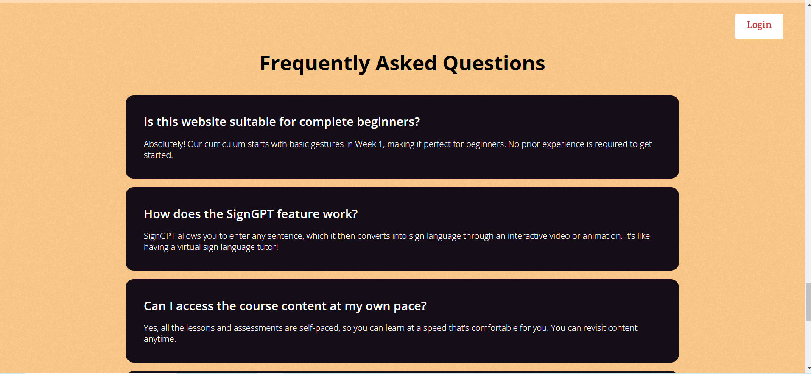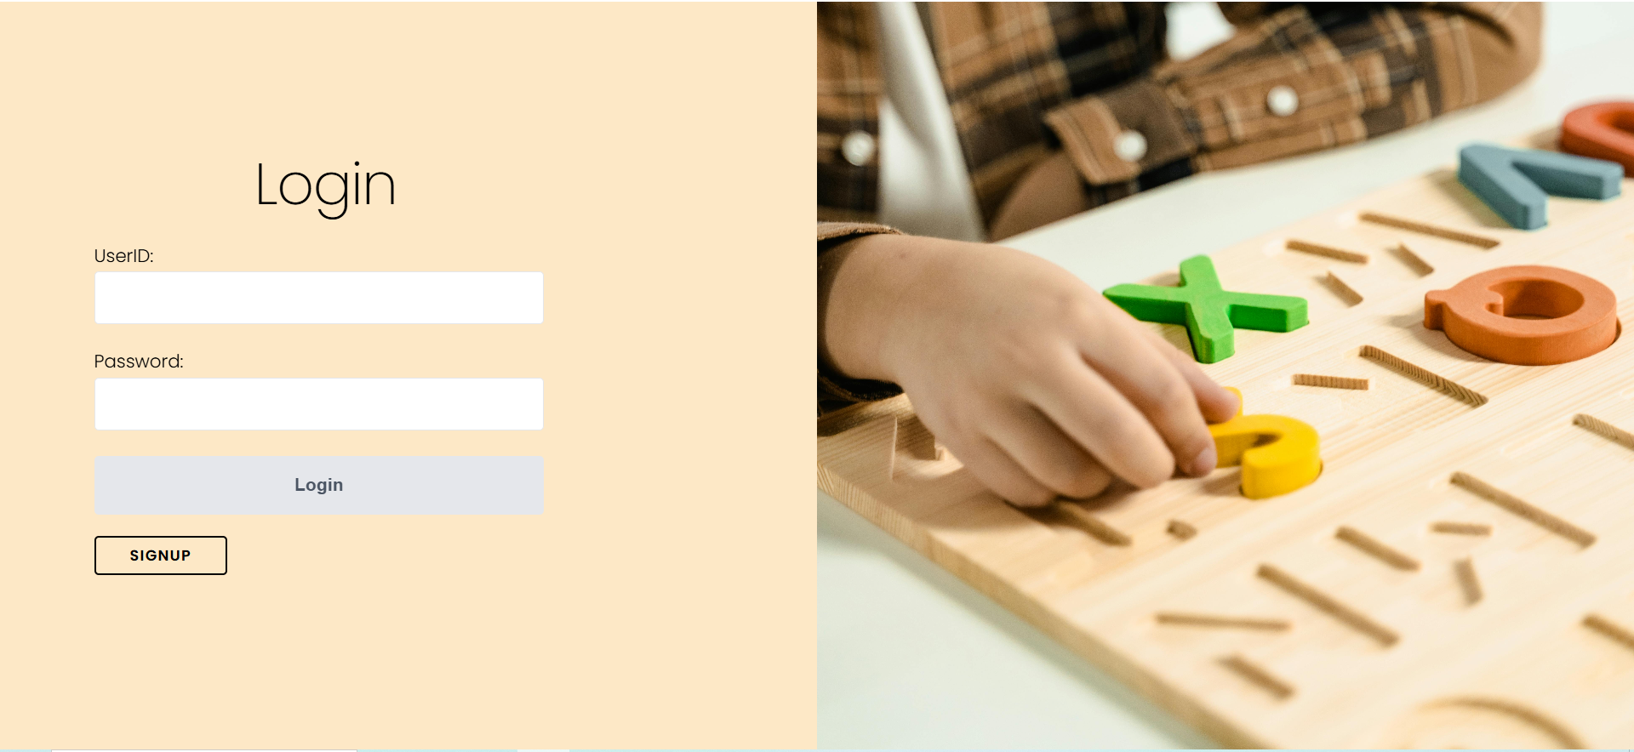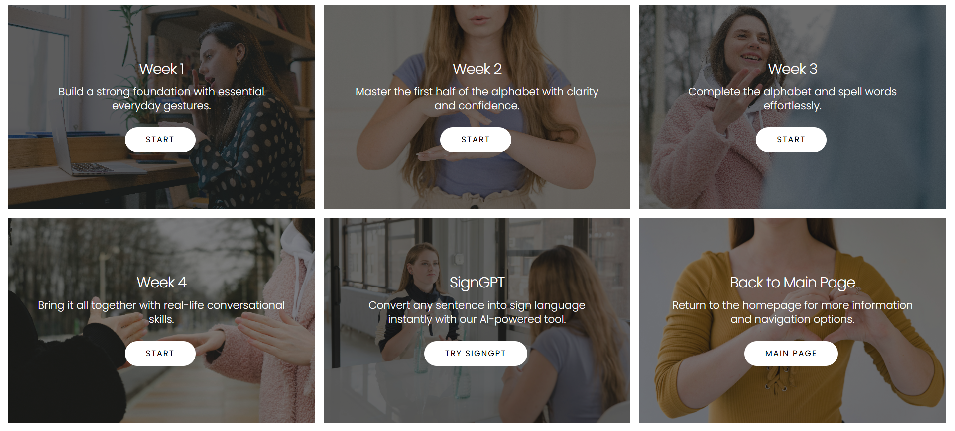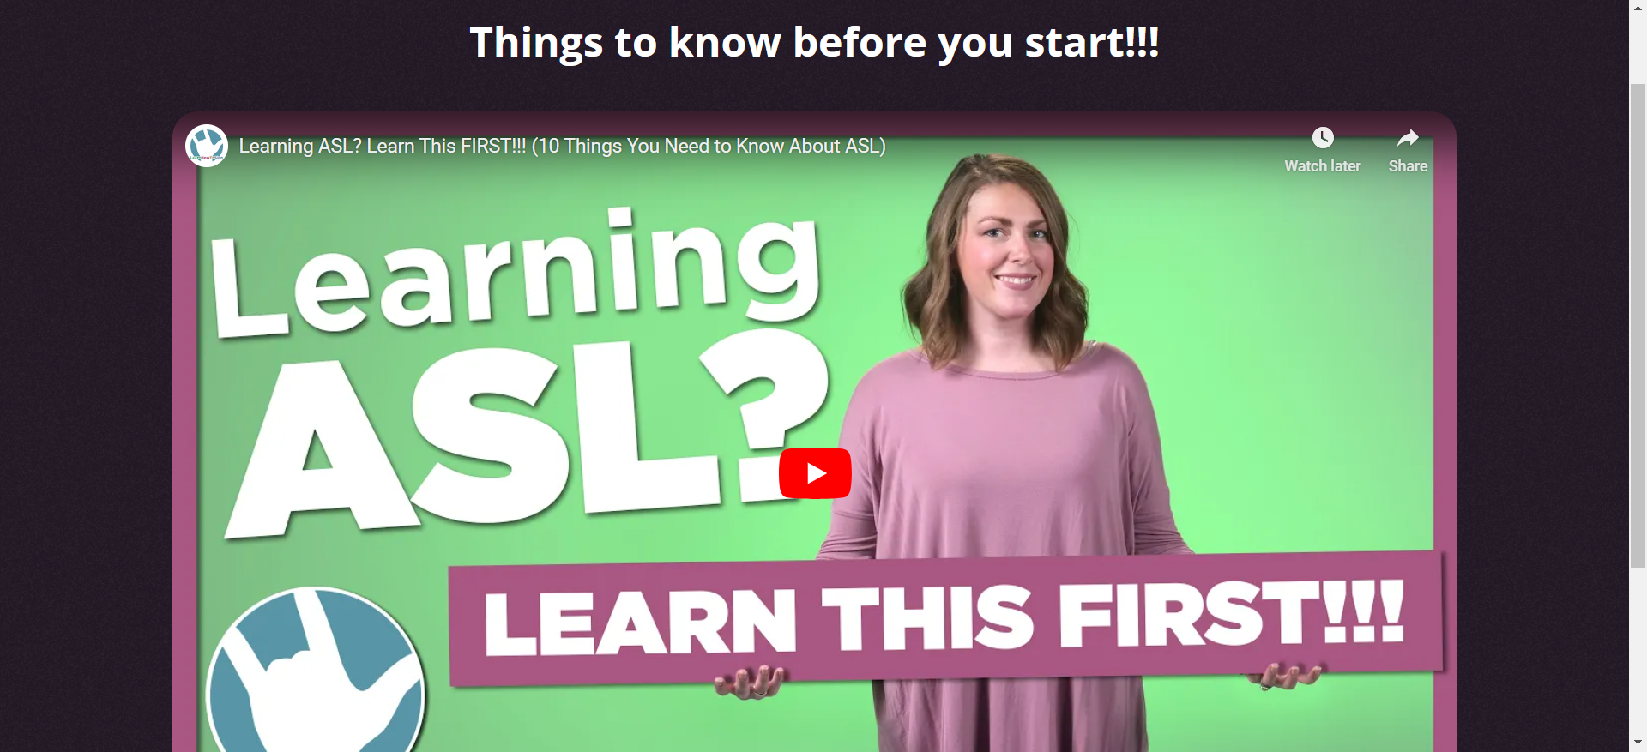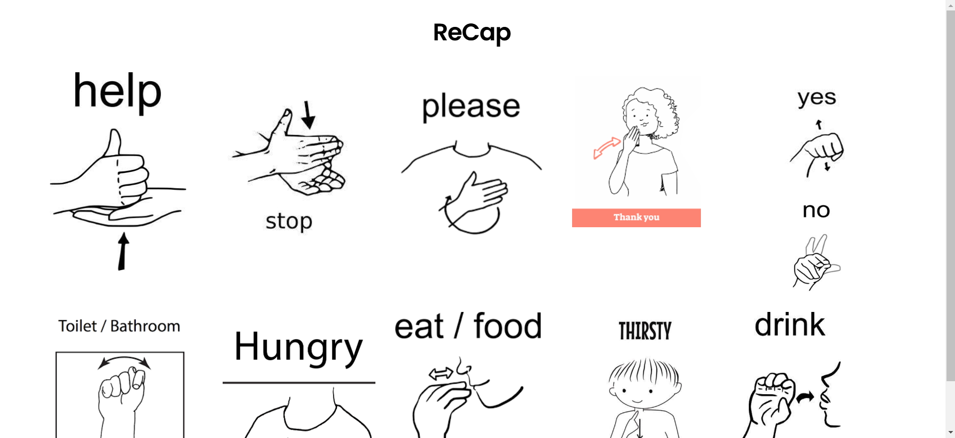

## 

## 

1. CONCLUSION

SignEase is a transformative platform that addresses the critical need for accessible sign language education. By combining AI-driven tools, interactive videos, and a structured curriculum, the platform fosters inclusivity and empowers specially-abled individuals. Future developments could include expanding the curriculum to cover regional sign languages and integrating VR-based immersive learning.

1. REFERENCES

# [Gabriel Serrano](https://ieeexplore.ieee.org/author/625139638237583); [Daehan Kwak](https://ieeexplore.ieee.org/author/37665291200); “Real-time Sign Language Recognition Using Computer Vision and AI”;  [2023 International Conference on Computational Science and Computational Intelligence (CSCI)](https://ieeexplore.ieee.org/xpl/conhome/10590067/proceeding)

# Tangfei Tao; Yizhe Zhao; Tianyu Liu; Jieli Zhu; “Sign Language Recognition: A Comprehensive Review of Traditional and Deep Learning Approaches, Datasets, and Challenges”; [IEEE Access](https://ieeexplore.ieee.org/xpl/RecentIssue.jsp?punumber=6287639) (Volume: 12)

# [Saurav Kumar](https://ieeexplore.ieee.org/author/38194909000); [Pratiyush Kumar](https://ieeexplore.ieee.org/author/115921246098609); [Priyesh Mishra](https://ieeexplore.ieee.org/author/797476244916522); [Pragya Tewari](https://ieeexplore.ieee.org/author/37089785420);“A Robust Sign Language and Hand Gesture Recognition System Using Convolutional Neural Networks”; [2023 5th International Conference on Advances in Computing, Communication Control and Networking (ICAC3N)](https://ieeexplore.ieee.org/xpl/conhome/10541113/proceeding)